Hinh 1 Usecase of Delivery

Hinh 2 Usecase of Owner

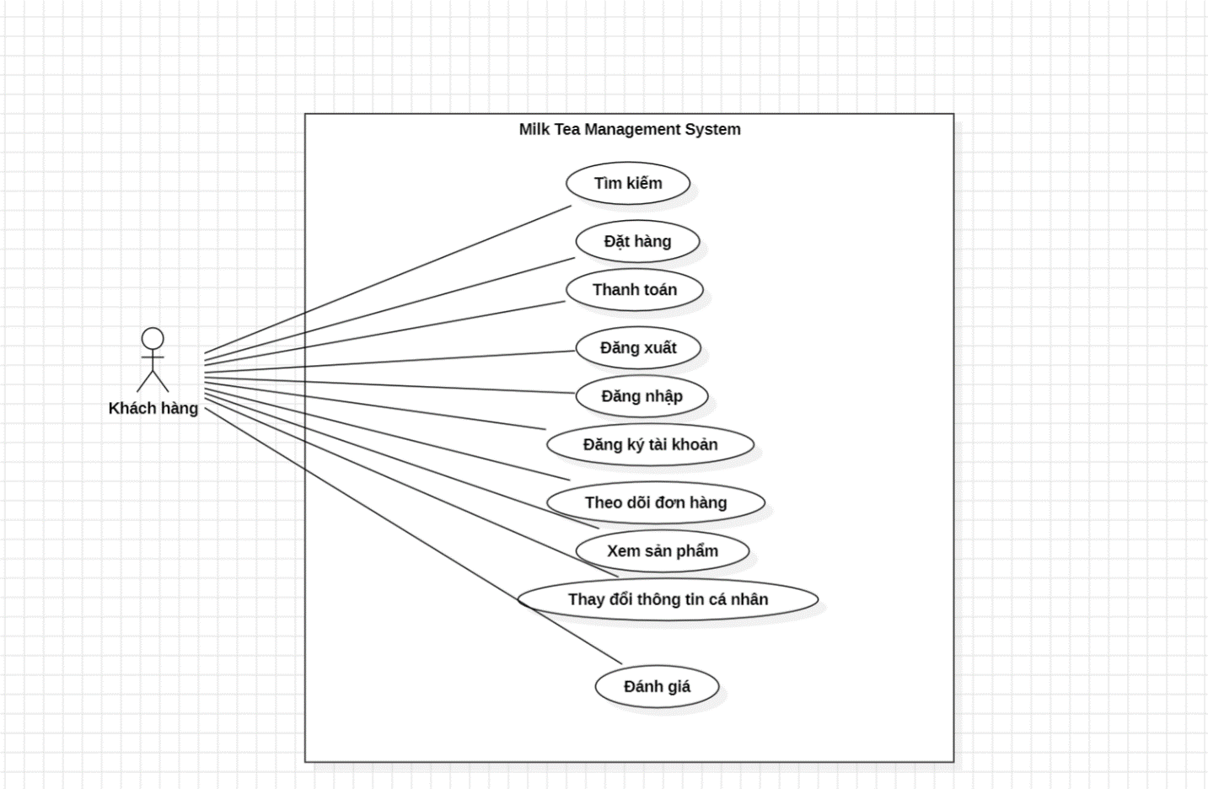

Hinh 3 Usecase of Customer

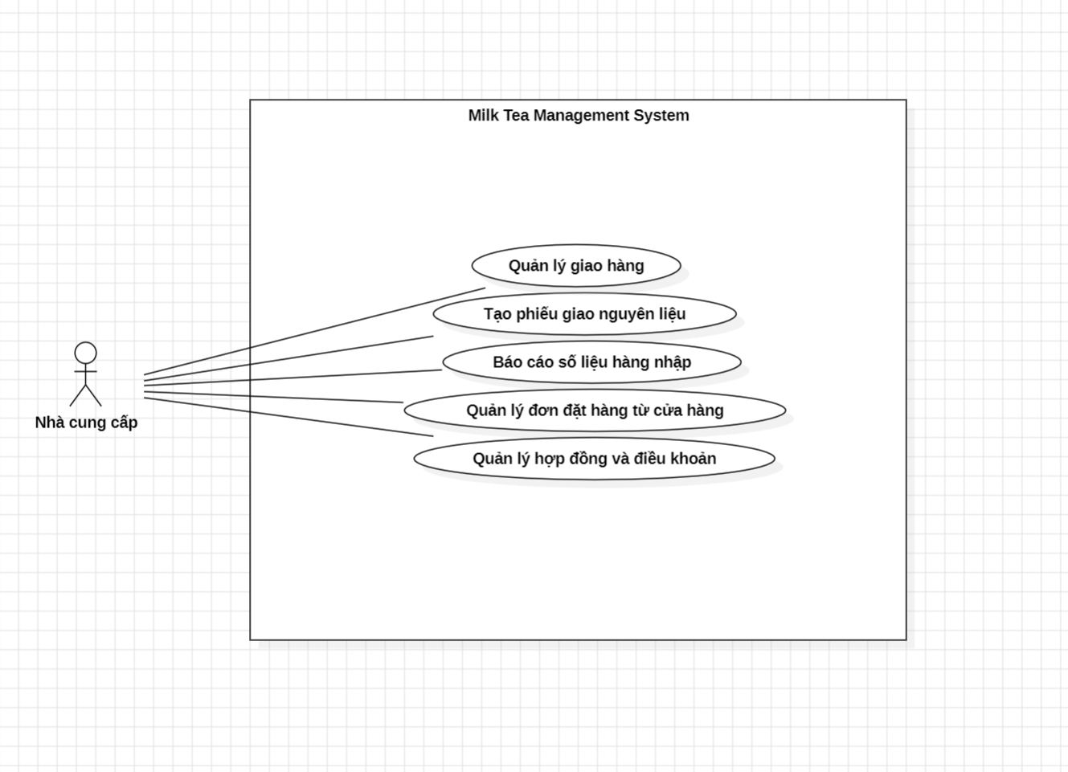

Hinh 4 Usecase of Supplier

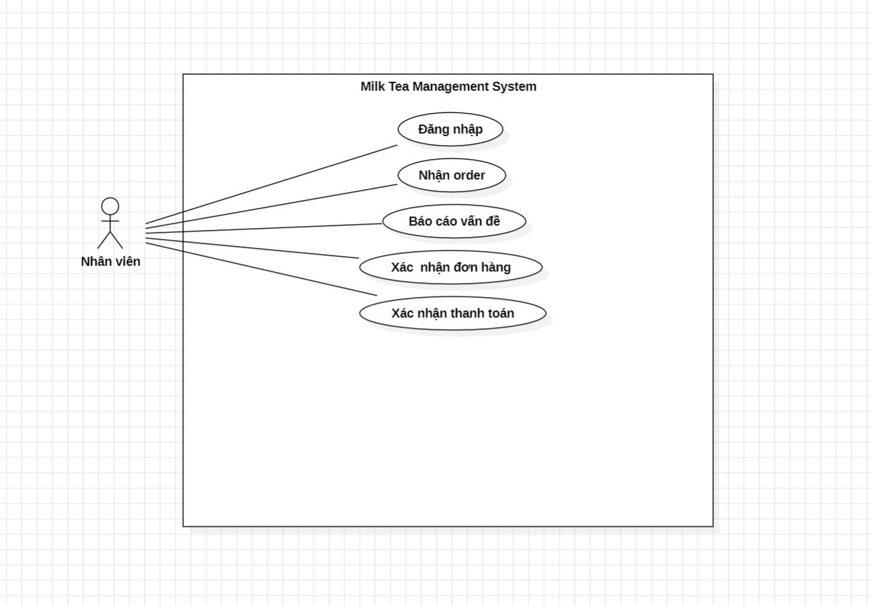

Hinh 5 Usecase of Staff